***TUT_4_20103153_Avni arora_B6***

1)

i)

Output:

***Note:***

**(Nothing is displayed as show function is not called any time in the code)**

But if we call show function in main() once then

Then output will be

a: 6

ii)

**Output:**

Count: 6

Count: 7

iii)

**Output:**

new called n Constructor called n Destructor called n delete called n

iv)

**Output:**

10

20

v)

**Output:**

x = 3,y = 2

2)

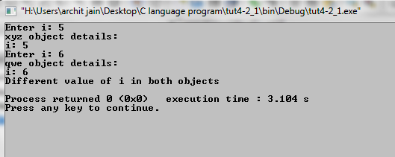i)

#include <iostream>

using namespace std;

class ASD

{

private:

int i;

public:

void operator == (ASD s1)

{

if(i==s1.i)

{

cout<<"Same value of i in both objects"<<endl;

}

else

cout<<"Different value of i in both objects"<<endl;

}

void get ()

{

cout<<"Enter i: ";

cin>>i;

}

void display()

{

cout<<"i: "<<i<<endl;

}

};

int main() {

ASD ASD,XYZ;

ASD.get();

cout<<"ASD object details:"<<endl;

ASD.display();

XYZ.get();

cout<<"XYZ object details:"<<endl;

XYZ.display();

ASD==XYZ;

return 0;

}

ii)

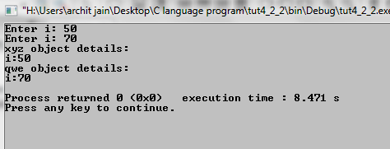#include <iostream>

using namespace std;

class ASD

{

private:

int i;

public:

friend ostream &operator<<(ostream&out,const ASD &s1)

{

out<<"i:"<<s1.i<<endl;

}

friend istream &operator>>(istream&in, ASD &s1)

{

cout<<"Enter i: ";

in>>s1.i;

}

};

int main() {

ASD ASD,XYZ;

cin>>ASD;

cin>>XYZ;

cout<<"ASD object details:"<<endl;

cout<<ASD;

cout<<"XYZ object details:"<<endl;

cout<<XYZ;

return 0;

}

iii)

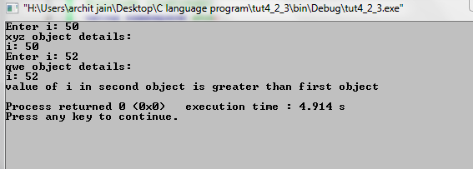#include <iostream>

using namespace std;

class ASD

{

private:

int i;

public:

void operator > (ASD s1)

{

if(i>s1.i)

{

cout<<"value of i in first object is greater than second object"<<endl;

}

}

void operator < (ASD s1)

{

if(i<s1.i)

{

cout<<"value of i in second object is greater than first object"<<endl;

}

}

void get ()

{

cout<<"Enter i: ";

cin>>i;

}

void display()

{

cout<<"i: "<<i<<endl;

}

};

int main() {

ASD ASD,XYZ;

ASD.get();

cout<<"ASD object details:"<<endl;

ASD.display();

XYZ.get();

cout<<"XYZ object details:"<<endl;

XYZ.display();

ASD>XYZ;

ASD<XYZ;

return 0;

}

Output:

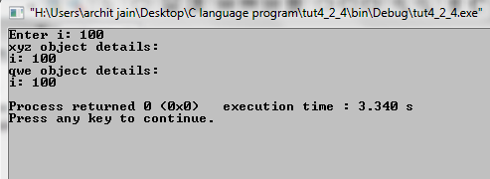iv)

#include <iostream>

using namespace std;

class ASD

{

private:

int i;

public:

void operator () (ASD &s1)

{

s1.i=i;

}

void get ()

{

cout<<"Enter i: ";

cin>>i;

}

void display()

{

cout<<"i: "<<i<<endl;

}

};

int main() {

ASD ASD,XYZ;

ASD.get();

cout<<"ASD object details:"<<endl;

ASD.display();

ASD(XYZ);

cout<<"XYZ object details:"<<endl;

XYZ.display();

return 0;

}

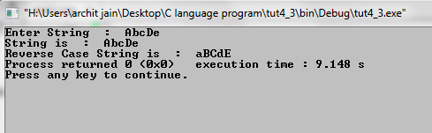3)

#include<iostream>

#include<string>

using namespace std;

class String

{

string str;

public:

void operator!()

{

for(int i=0; str[i]!='\0'; i++)

{

if(str[i]>=65&&str[i]<=96)

{

str[i]=str[i]+32;

}

else if(str[i]>=97&&str[i]<=122)

{

str[i]=str[i]-32;

}

}

cout<<"Reverse Case String is : "<<str;

}

String()

{

cout<<"Enter String : ";

cin>>str;

}

void display()

{

cout<<"String is : ";

cout<<str<<endl;

}

};

int main()

{

String s1;

s1.display();

!s1;

return 0;

}